Lecture 5: How does GPT-3 really work?
We are going to see how the versions of GPT evolved, how different papers on GPT evolved, what’s the progression from Transformers to GPT, to GPT-2, to GPT-3 and finally GPT-4.

Progression of Research Papers: Transformers → GPT → GPT-2 → GPT-3 → GPT-4

1. Transformers – Attention Is All You Need (2017)
This paper was a major breakthrough because it introduced the self-attention mechanism, which captures long-range dependencies and allows better prediction of the next word. It was a significant advancement compared to RNNs and LSTMs. The transformer architecture introduced in this paper truly changed everything. The original architecture had both an encoder and a decoder, but the GPT architecture that came later removed the encoder and used only the decoder.

2. GPT-1 – Improving Language Understanding by Generative Pre-Training (2018)
This paper came out after the transformers paper and introduced the concept of generative pre-training. The main idea was unsupervised learning. NLP contains a very wide range of tasks, but labeled data is scarce and makes training difficult.
They showed that a model can generalize by generative pre-training on a diverse corpus of unlabeled text—using whatever appears in a sentence as training data and predicting the next word as the target, without any labeling.
They kept only the decoder from the transformer and removed the encoder, training the model purely for next-word prediction. OpenAI also released a blog claiming state-of-the-art results using transformers and unsupervised pretraining.
At that time, it was a big deal for researchers, but in the commercial world most students and professors had not heard much about it—it was still mainly a research project.

3. GPT-2 – Language Models Are Unsupervised Multitask Learners (2019)
In this work, they used much more data and scaled up the generative pre-training approach. They introduced several model sizes, and the largest version had 1.5 billion (1542M) parameters.
This was the first time a paper described an LLM of around one billion parameters. At the same time, OpenAI was already working on even larger models. A model with “thousand million” parameters was unprecedented.

4. GPT-3 – Language Models Are Few-Shot Learners (2020) – The Real Breakthrough
GPT-3 truly changed everything. It had 175 billion parameters and multiple versions. When people started exploring this model, they realized it was amazing—it could perform many different tasks with little or no training.
This was a size of model that people had never seen before, and it quickly became commercially viral.

5. GPT-4 (2022)
About two years later, GPT-4 was released, representing another major leap in capability and performance.

1.Zero Shot vs Few Shot Learning
- Zero Shot: Ability to generalize to completely unseen tasks without any prior specific examples.
- Few Shot: Learning from a minimum number of examples which the user provides as input.
In GPT-3 papers they have an illustration, zero shot, tell model to translate from English to French, No gradient updates are performed, there is also one-shot learning, model also sees a single example of the task, no gradient updates are performed, few-shot, in addition to task description, the model sees a few examples of the task. No gradient updates are performed.
The claim of GPT-3 authors: they train GPT-3 an autoregressive language model with 175 billion parameters, 10 times more than any previous models and test the performance in the few-shot setting, GPT-3 achieves strong performance on many tasks that requires on-the-fly reasoning or domain adaptation, such as unscrambling words, using novel words in sentence, or performing 3 digits arithmetic, If it is giving certain examples it can do the task very well, although it is only. Trained for next word prediction. So they claim it is a few-shot learner.

What about GPT-4? Zero-shot or few-shot, it does many things on its own, without being given examples? It can do zero-shot learner, but does much well at few-shot learning. It has both capabilities, but does more accurate responses as a few shot-learner.

When we think of LLMs, this distinction is very important because as we move to higher models, zero-shot learning becomes better.

2. Utilizing Large Datasets

GPT-3 used:
- Common Crawl datasets, can be used by anyone, free and open corpus, uses 410 billion tokens from that, 410 billion tokens (60%)
- WebText2, covers all reddit submissions from 2005 to 2020 19 billion tokens (22%)
- Books1
- Books2
- Wikipedia

Token is a unit of a text which the model reads.
Pre-training GPT-3 is not easy, you need huge computational power. The total pre-training cost of GPT-3 is 4.6 million dollars (access to GPUs).

>> These pretrained models are base/foundational models which can be used for further finetuning
>> Many pre-trained LLMs are available as open-source models >> can be used as general purpose tools to write, extract and edit text which was not part of the training data.

Open-source vs Close-source LLMS:
GPT-4 is a closed source model, you can just use the output as an interphase, but there are many open-source models have been introduced but the performance not as good as GPT-4. Now as we entering August, performance of open-source models is comparable,

Llama 3.1 LLM open-source model, most powerful open-source models released by Meta, performance. A bit better than GPT-4, gap is closing.
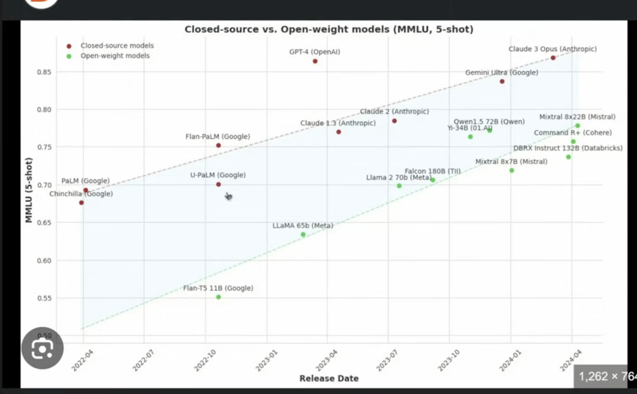
3. GPT-3 Architecture
GPT architecture has only decoder block, GPT-3 is a scaled up version of the official model (2018), implemented on a large dataset.

Autoregressive Models

- GPT-models are simply trained on “next-word” prediction tasks, at every stage of training process, the input consists of few words, but the output is just one word, there ae no labels, the sentence breaks into parts, that’s why it called unsupervised learning, because sentence itself creates label, label is the next word.
- With this training, they can still do a wide range of other tasks, like translation, spelling correction, etc.
- Next-word prediction: self-supervised learning (Self labeling) >> This requires huge amount of power. Initially it will predict wrong outputs but we have the correct output error will be difference between them and them similar to back propagation the weights of the transformer will adapt so that next word is predicted correctly. Train to minimize the difference and update weights. You do not have to externally label.
- We do not collect labels for training data, but use the structure of the data itself (hence called autoregressive)
- One more reason, is the previous out is used as an input for future prediction.

Pre-training:
- Unsupervised: do not externally collect labels
- Auto Regressive, previous outputs are used as inputs for future predictions.

Why so much compute power?

GPT-Architecture:
It is a bit simpler than transformer, it only has the decoder block. Input text is only passed to the decoder, in a sense it is simpler, but also the number of building blocks used is huge in GPT.
Original transformer: 6 encoder-decoder blocks
GPT-3: 96 transformer layers (96 blocks)
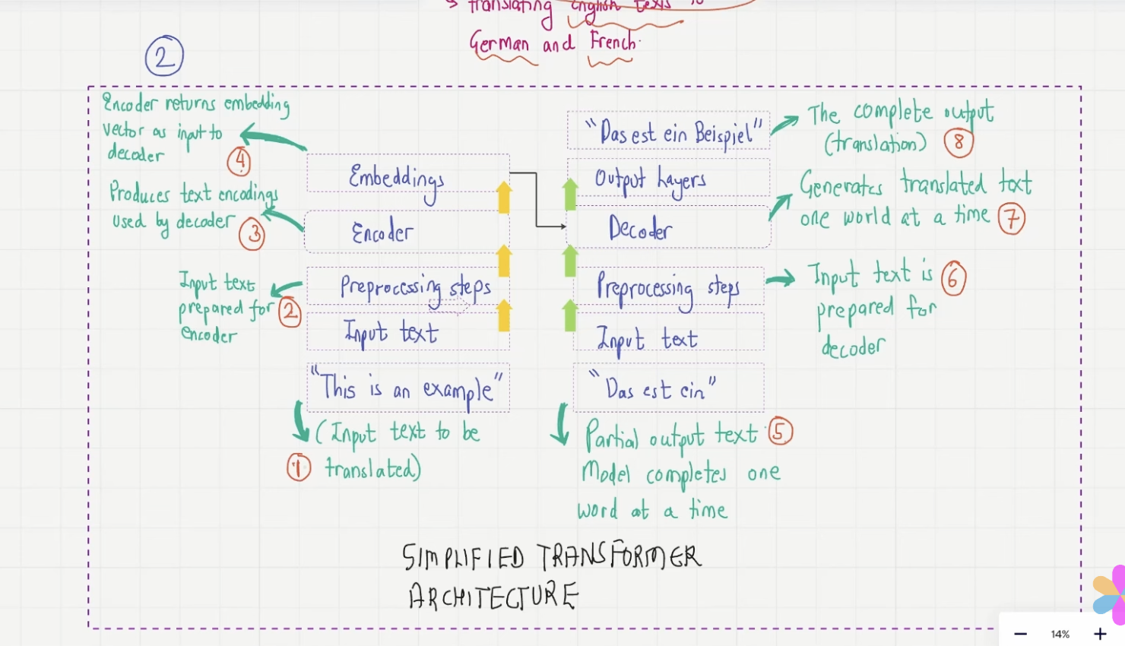
Emergent Behaviour:
Although trained only for next word prediction, GPT model can perform other tasks like language translation. This is called “emergent behaviour: Ability of a model to perform tasks that the model was not trained for. We notices we can use it the model to performing task without ever training on them. Area of active research.

